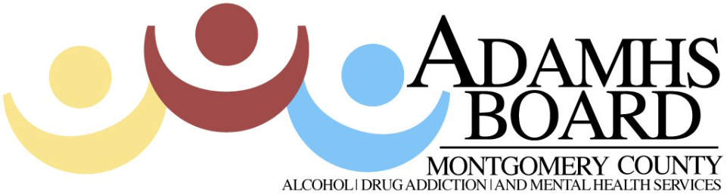
Presents

Community Partnerships to Study and Reduce Harm from Prescription Drugs
Since 2007, unintentional drug overdoses have been the leading cause of accidental death in Ohio. Fatal and non-fatal poisonings cost Ohioans $3.6 billion annually. Prescription painkillers accounted for nearly 37% of unintentional overdose deaths in 2008. (Ohio Department of Health)

When: Wednesday, May 9, 2012
Where: Dayton Masonic Center
525 W. Riverview Avenue
Dayton, Ohio 45405
Banquet Room/Lower Level
Time: Registration 12:30-1:00
Training from 1:00 P.M. – 3:00 P.M.
Cost: This training is FREE of charge
Presenter: Christy Porucznik, PhD, MSPH Assistant Professor in the Public Health Program at the University of Utah will share the partnerships undertaken by substance abuse stakeholders in Utah to address the problem of prescription opioid-related harm. Christy will help Montgomery County identify local data gaps and strategize about how to obtain data for surveillance and evaluation.

Send completed registration form to Darla Rudolph via email at drudolph@mcadamhs.org or via fax at (937) 461-8396

Participants will earn 2.0 RCHs as approved by The Ohio Chemical Dependency Professionals Board under Provider Status #02-1012-34PVN-R and has earned 2.0 CPEs as approved by the State of Ohio Counselor, Social Worker and Marriage & Family Therapist Board under Approval #RCX111001

Registration Form

Name Phone

Address City/State/Zip

E-mail

Do you need continuing education? YES NO

Registration deadline: May 2, 2012 but registrations will be taken until we’ve reached capacity.

